|  |
| --- |
| The SAS System |

The LOGISTIC Procedure

| **Model Information** | |
| --- | --- |
| **Data Set** | WORK.TRDATA |
| **Response Variable** | Outcome |
| **Number of Response Levels** | 2 |
| **Model** | binary logit |
| **Optimization Technique** | Fisher's scoring |

|  |  |
| --- | --- |
| **Number of Observations Read** | 7436 |
| **Number of Observations Used** | 7436 |

| **Response Profile** | | |
| --- | --- | --- |
| **Ordered Value** | **Outcome** | **Total Frequency** |
| **1** | 0 | 5637 |
| **2** | 1 | 1799 |

|  |
| --- |
| **Probability modeled is Outcome=0.** |

|  |
| --- |
| **Stepwise Selection Procedure** |

|  |
| --- |
| **Step 0. Intercept entered:** |

| **Model Convergence Status** |
| --- |
| Convergence criterion (GCONV=1E-8) satisfied. |

|  |  |  |
| --- | --- | --- |
| **-2 Log L** | = | 8228.614 |

| **Residual Chi-Square Test** | | |
| --- | --- | --- |
| **Chi-Square** | **DF** | **Pr > ChiSq** |
| 245.3731 | 31 | <.0001 |

|  |
| --- |
| **Step 1. Effect impair entered:** |

| **Model Convergence Status** |
| --- |
| Convergence criterion (GCONV=1E-8) satisfied. |

| **Model Fit Statistics** | | |
| --- | --- | --- |
| **Criterion** | **Intercept Only** | **Intercept and Covariates** |
| **AIC** | 8230.614 | 8063.089 |
| **SC** | 8237.528 | 8076.917 |
| **-2 Log L** | 8228.614 | 8059.089 |

| **Testing Global Null Hypothesis: BETA=0** | | | |
| --- | --- | --- | --- |
| **Test** | **Chi-Square** | **DF** | **Pr > ChiSq** |
| **Likelihood Ratio** | 169.5250 | 1 | <.0001 |
| **Score** | 196.8494 | 1 | <.0001 |
| **Wald** | 176.5151 | 1 | <.0001 |

| **Residual Chi-Square Test** | | |
| --- | --- | --- |
| **Chi-Square** | **DF** | **Pr > ChiSq** |
| 43.6948 | 30 | 0.0508 |

|  |  |
| --- | --- |
| Note: | No effects for the model in Step 1 are removed. |

|  |  |
| --- | --- |
| Note: | No (additional) effects met the 0.05 significance level for entry into the model. |

| **Summary of Stepwise Selection** | | | | | | | |
| --- | --- | --- | --- | --- | --- | --- | --- |
| **Step** | **Effect** | | **DF** | **Number In** | **Score Chi-Square** | **Wald Chi-Square** | **Pr > ChiSq** |
| **Entered** | **Removed** |
| **1** | **impair** |  | 1 | 1 | 196.8494 |  | <.0001 |

| **Analysis of Maximum Likelihood Estimates** | | | | | |
| --- | --- | --- | --- | --- | --- |
| **Parameter** | **DF** | **Estimate** | **Standard Error** | **Wald Chi-Square** | **Pr > ChiSq** |
| **Intercept** | 1 | 1.2442 | 0.0288 | 1871.0445 | <.0001 |
| **impair** | 1 | -1.2730 | 0.0958 | 176.5151 | <.0001 |

| **Odds Ratio Estimates** | | | |
| --- | --- | --- | --- |
| **Effect** | **Point Estimate** | **95% Wald Confidence Limits** | |
| **impair** | 0.280 | 0.232 | 0.338 |

| **Association of Predicted Probabilities and Observed Responses** | | | |
| --- | --- | --- | --- |
| **Percent Concordant** | 12.9 | **Somers' D** | 0.093 |
| **Percent Discordant** | 3.6 | **Gamma** | 0.563 |
| **Percent Tied** | 83.5 | **Tau-a** | 0.034 |
| **Pairs** | 10140963 | **c** | 0.546 |

|  |
| --- |
| The SAS System |

The FACTOR Procedure

|  |  |
| --- | --- |
| **Input Data Type** | Raw Data |
| **Number of Records Read** | 7436 |
| **Number of Records Used** | 7436 |
| **N for Significance Tests** | 7436 |

|  |
| --- |
| The SAS System |

The FACTOR Procedure

Initial Factor Method: Principal Components

|  |
| --- |
| **Prior Communality Estimates: ONE** |

| **Eigenvalues of the Correlation Matrix: Total = 5 Average = 1** | | | | |
| --- | --- | --- | --- | --- |
|  | **Eigenvalue** | **Difference** | **Proportion** | **Cumulative** |
| **1** | 1.81375255 | 0.77296390 | 0.3628 | 0.3628 |
| **2** | 1.04078866 | 0.04849979 | 0.2082 | 0.5709 |
| **3** | 0.99228886 | 0.04424245 | 0.1985 | 0.7694 |
| **4** | 0.94804642 | 0.74292291 | 0.1896 | 0.9590 |
| **5** | 0.20512351 |  | 0.0410 | 1.0000 |

|  |
| --- |
| **5 factors will be retained by the NFACTOR criterion.** |

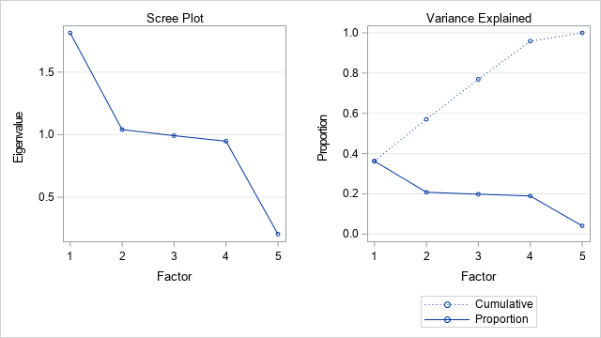

| **Factor Pattern** | | | | | |
| --- | --- | --- | --- | --- | --- |
|  | **Factor1** | **Factor2** | **Factor3** | **Factor4** | **Factor5** |
| **wethsev** | 0.94007 | 0.09669 | 0.00155 | 0.06760 | -0.31992 |
| **timeofday** | -0.18936 | 0.60795 | -0.21585 | 0.74020 | 0.00691 |
| **datew** | -0.07390 | 0.33682 | 0.93866 | -0.00020 | -0.00356 |
| **impair** | -0.04282 | 0.73557 | -0.25362 | -0.62673 | 0.00068 |
| **surfcond** | 0.94174 | 0.08560 | 0.01718 | 0.05285 | 0.32049 |

| **Variance Explained by Each Factor** | | | | |
| --- | --- | --- | --- | --- |
| **Factor1** | **Factor2** | **Factor3** | **Factor4** | **Factor5** |
| 1.8137526 | 1.0407887 | 0.9922889 | 0.9480464 | 0.2051235 |

| **Final Communality Estimates: Total = 5.000000** | | | | |
| --- | --- | --- | --- | --- |
| **wethsev** | **timeofday** | **datew** | **impair** | **surfcond** |
| 1.0000000 | 1.0000000 | 1.0000000 | 1.0000000 | 1.0000000 |

|  |
| --- |
| The SAS System |

The FACTOR Procedure

Rotation Method: Varimax

| **Orthogonal Transformation Matrix** | | | | | |
| --- | --- | --- | --- | --- | --- |
|  | **1** | **2** | **3** | **4** | **5** |
| **1** | 0.98721 | -0.14397 | -0.05606 | -0.03236 | 0.02215 |
| **2** | 0.12924 | 0.59549 | 0.32999 | 0.72096 | -0.00129 |
| **3** | 0.01340 | -0.21680 | 0.94231 | -0.25463 | 0.00652 |
| **4** | 0.08981 | 0.75999 | -0.00033 | -0.64369 | -0.00402 |
| **5** | -0.02143 | 0.00843 | -0.00448 | 0.00072 | 0.99972 |

| **Rotated Factor Pattern** | | | | | |
| --- | --- | --- | --- | --- | --- |
|  | **Factor1** | **Factor2** | **Factor3** | **Factor4** | **Factor5** |
| **wethsev** | 0.95349 | -0.02942 | -0.01793 | -0.00485 | -0.29940 |
| **timeofday** | -0.04493 | 0.99869 | 0.00756 | 0.02295 | -0.00245 |
| **datew** | -0.01678 | 0.00753 | 0.99981 | 0.00635 | 0.00048 |
| **impair** | -0.00690 | 0.02287 | 0.00635 | 0.99969 | -0.00035 |
| **surfcond** | 0.93887 | -0.04547 | -0.00982 | -0.00692 | 0.34105 |

| **Variance Explained by Each Factor** | | | | |
| --- | --- | --- | --- | --- |
| **Factor1** | **Factor2** | **Factor3** | **Factor4** | **Factor5** |
| 1.7929725 | 1.0009046 | 1.0001364 | 1.0000271 | 0.2059594 |

| **Final Communality Estimates: Total = 5.000000** | | | | |
| --- | --- | --- | --- | --- |
| **wethsev** | **timeofday** | **datew** | **impair** | **surfcond** |
| 1.0000000 | 1.0000000 | 1.0000000 | 1.0000000 | 1.0000000 |

|  |
| --- |
| The SAS System |

The FACTOR Procedure

Rotation Method: Varimax

|  |
| --- |
| **Scoring Coefficients Estimated by Regression** |

| **Squared Multiple Correlations of the Variables with Each Factor** | | | | |
| --- | --- | --- | --- | --- |
| **Factor1** | **Factor2** | **Factor3** | **Factor4** | **Factor5** |
| 1.0000000 | 1.0000000 | 1.0000000 | 1.0000000 | 1.0000000 |

| **Standardized Scoring Coefficients** | | | | | |
| --- | --- | --- | --- | --- | --- |
|  | **Factor1** | **Factor2** | **Factor3** | **Factor4** | **Factor5** |
| **wethsev** | 0.56353 | 0.02141 | 0.01003 | 0.00279 | -1.54812 |
| **timeofday** | 0.03891 | 1.00369 | -0.00678 | -0.02264 | 0.02605 |
| **datew** | 0.01464 | -0.00681 | 1.00053 | -0.00610 | -0.01253 |
| **impair** | 0.00517 | -0.02271 | -0.00610 | 1.00090 | 0.00287 |
| **surfcond** | 0.49497 | 0.02600 | 0.00733 | 0.00333 | 1.57329 |

|  |
| --- |
| The SAS System |

The MEANS Procedure

CLUSTER=1

| **Analysis Variable : Outcome** | | | | |
| --- | --- | --- | --- | --- |
| **N** | **Mean** | **Std Dev** | **Minimum** | **Maximum** |
| 1708 | 0.2265808 | 0.4187417 | 0 | 1.0000000 |

CLUSTER=2

| **Analysis Variable : Outcome** | | | | |
| --- | --- | --- | --- | --- |
| **N** | **Mean** | **Std Dev** | **Minimum** | **Maximum** |
| 1501 | 0.2178548 | 0.4129257 | 0 | 1.0000000 |

CLUSTER=3

| **Analysis Variable : Outcome** | | | | |
| --- | --- | --- | --- | --- |
| **N** | **Mean** | **Std Dev** | **Minimum** | **Maximum** |
| 2008 | 0.2241036 | 0.4170945 | 0 | 1.0000000 |

CLUSTER=4

| **Analysis Variable : Outcome** | | | | |
| --- | --- | --- | --- | --- |
| **N** | **Mean** | **Std Dev** | **Minimum** | **Maximum** |
| 1742 | 0.2256028 | 0.4180987 | 0 | 1.0000000 |

CLUSTER=5

| **Analysis Variable : Outcome** | | | | |
| --- | --- | --- | --- | --- |
| **N** | **Mean** | **Std Dev** | **Minimum** | **Maximum** |
| 477 | 0.5073375 | 0.5004710 | 0 | 1.0000000 |

|  |
| --- |
| The SAS System |

The GLM Procedure

| **Class Level Information** | | |
| --- | --- | --- |
| **Class** | **Levels** | **Values** |
| **CLUSTER** | 5 | 1 2 3 4 5 |

|  |  |
| --- | --- |
| **Number of Observations Read** | 7436 |
| **Number of Observations Used** | 7436 |

|  |
| --- |
| The SAS System |

The GLM Procedure

Dependent Variable: Outcome

| **Source** | **DF** | **Sum of Squares** | **Mean Square** | **F Value** | **Pr > F** |
| --- | --- | --- | --- | --- | --- |
| **Model** | 4 | 35.975322 | 8.993831 | 50.33 | <.0001 |
| **Error** | 7431 | 1327.790546 | 0.178683 |  |  |
| **Corrected Total** | 7435 | 1363.765869 |  |  |  |

| **R-Square** | **Coeff Var** | **Root MSE** | **Outcome Mean** |
| --- | --- | --- | --- |
| 0.026379 | 174.7227 | 0.422709 | 0.241931 |

| **Source** | **DF** | **Type I SS** | **Mean Square** | **F Value** | **Pr > F** |
| --- | --- | --- | --- | --- | --- |
| **CLUSTER** | 4 | 35.97532234 | 8.99383058 | 50.33 | <.0001 |

| **Source** | **DF** | **Type III SS** | **Mean Square** | **F Value** | **Pr > F** |
| --- | --- | --- | --- | --- | --- |
| **CLUSTER** | 4 | 35.97532234 | 8.99383058 | 50.33 | <.0001 |

| **Contrast** | **DF** | **Contrast SS** | **Mean Square** | **F Value** | **Pr > F** |
| --- | --- | --- | --- | --- | --- |
| **last cluster different** | 1 | 35.93015854 | 35.93015854 | 201.08 | <.0001 |

|  |
| --- |
| The SAS System |

The TTEST Procedure

Variable: Outcome

| **sample** | **Method** | **N** | **Mean** | **Std Dev** | **Std Err** | **Minimum** | **Maximum** |
| --- | --- | --- | --- | --- | --- | --- | --- |
| **subset** |  | 477 | 0.5073 | 0.5005 | 0.0229 | 0 | 1.0000 |
| **total** |  | 7436 | 0.2419 | 0.4283 | 0.00497 | 0 | 1.0000 |
| **Diff (1-2)** | **Pooled** |  | 0.2654 | 0.4330 | 0.0205 |  |  |
| **Diff (1-2)** | **Satterthwaite** |  | 0.2654 |  | 0.0234 |  |  |

| **sample** | **Method** | **Mean** | **95% CL Mean** | | **Std Dev** | **95% CL Std Dev** | |
| --- | --- | --- | --- | --- | --- | --- | --- |
| **subset** |  | 0.5073 | 0.4623 | 0.5524 | 0.5005 | 0.4706 | 0.5344 |
| **total** |  | 0.2419 | 0.2322 | 0.2517 | 0.4283 | 0.4215 | 0.4353 |
| **Diff (1-2)** | **Pooled** | 0.2654 | 0.2253 | 0.3055 | 0.4330 | 0.4263 | 0.4398 |
| **Diff (1-2)** | **Satterthwaite** | 0.2654 | 0.2193 | 0.3115 |  |  |  |

| **Method** | **Variances** | **DF** | **t Value** | **Pr > |t|** |
| --- | --- | --- | --- | --- |
| **Pooled** | Equal | 7911 | 12.98 | <.0001 |
| **Satterthwaite** | Unequal | 521.7 | 11.32 | <.0001 |

| **Equality of Variances** | | | | |
| --- | --- | --- | --- | --- |
| **Method** | **Num DF** | **Den DF** | **F Value** | **Pr > F** |
| **Folded F** | 476 | 7435 | 1.37 | <.0001 |

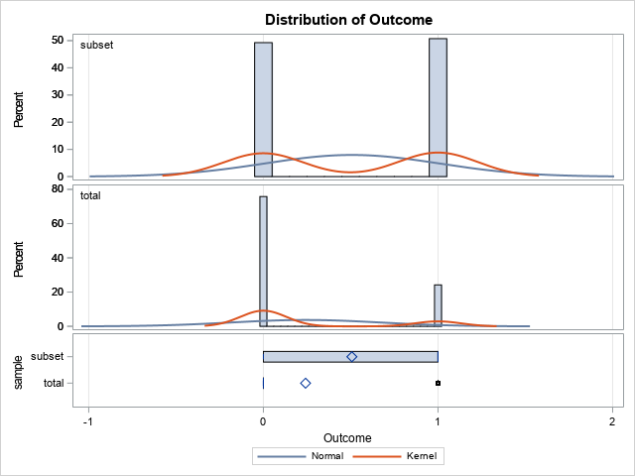

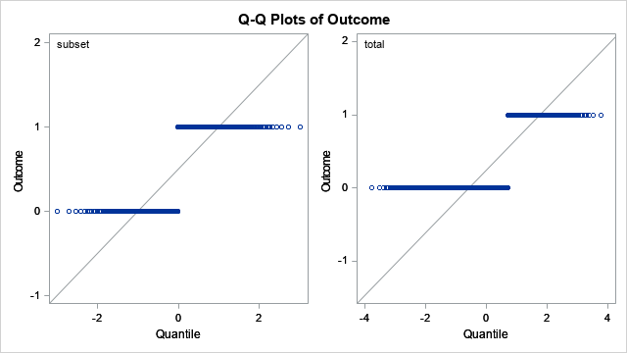

|  |
| --- |
| **Variable: wethsev** |

| **sample** | **Method** | **N** | **Mean** | **Std Dev** | **Std Err** | **Minimum** | **Maximum** |
| --- | --- | --- | --- | --- | --- | --- | --- |
| **subset** |  | 477 | 0.7547 | 1.2836 | 0.0588 | 0 | 4.0000 |
| **total** |  | 7436 | 0.8155 | 1.3474 | 0.0156 | 0 | 4.0000 |
| **Diff (1-2)** | **Pooled** |  | -0.0608 | 1.3437 | 0.0635 |  |  |
| **Diff (1-2)** | **Satterthwaite** |  | -0.0608 |  | 0.0608 |  |  |

| **sample** | **Method** | **Mean** | **95% CL Mean** | | **Std Dev** | **95% CL Std Dev** | |
| --- | --- | --- | --- | --- | --- | --- | --- |
| **subset** |  | 0.7547 | 0.6392 | 0.8702 | 1.2836 | 1.2070 | 1.3707 |
| **total** |  | 0.8155 | 0.7849 | 0.8461 | 1.3474 | 1.3261 | 1.3694 |
| **Diff (1-2)** | **Pooled** | -0.0608 | -0.1852 | 0.0636 | 1.3437 | 1.3231 | 1.3650 |
| **Diff (1-2)** | **Satterthwaite** | -0.0608 | -0.1802 | 0.0587 |  |  |  |

| **Method** | **Variances** | **DF** | **t Value** | **Pr > |t|** |
| --- | --- | --- | --- | --- |
| **Pooled** | Equal | 7911 | -0.96 | 0.3383 |
| **Satterthwaite** | Unequal | 545.49 | -1.00 | 0.3181 |

| **Equality of Variances** | | | | |
| --- | --- | --- | --- | --- |
| **Method** | **Num DF** | **Den DF** | **F Value** | **Pr > F** |
| **Folded F** | 7435 | 476 | 1.10 | 0.1583 |

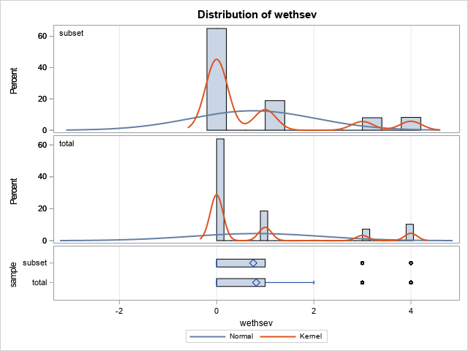

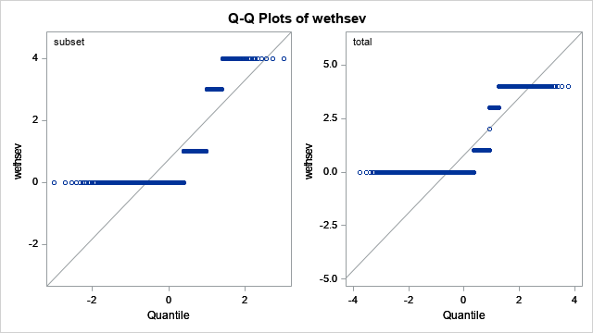

|  |
| --- |
| **Variable: timeofday** |

| **sample** | **Method** | **N** | **Mean** | **Std Dev** | **Std Err** | **Minimum** | **Maximum** |
| --- | --- | --- | --- | --- | --- | --- | --- |
| **subset** |  | 477 | 2.7757 | 1.2170 | 0.0557 | 1.0000 | 4.0000 |
| **total** |  | 7436 | 2.6280 | 0.8159 | 0.00946 | 1.0000 | 4.0000 |
| **Diff (1-2)** | **Pooled** |  | 0.1477 | 0.8454 | 0.0399 |  |  |
| **Diff (1-2)** | **Satterthwaite** |  | 0.1477 |  | 0.0565 |  |  |

| **sample** | **Method** | **Mean** | **95% CL Mean** | | **Std Dev** | **95% CL Std Dev** | |
| --- | --- | --- | --- | --- | --- | --- | --- |
| **subset** |  | 2.7757 | 2.6662 | 2.8852 | 1.2170 | 1.1444 | 1.2996 |
| **total** |  | 2.6280 | 2.6095 | 2.6466 | 0.8159 | 0.8030 | 0.8292 |
| **Diff (1-2)** | **Pooled** | 0.1477 | 0.0694 | 0.2259 | 0.8454 | 0.8324 | 0.8588 |
| **Diff (1-2)** | **Satterthwaite** | 0.1477 | 0.0366 | 0.2587 |  |  |  |

| **Method** | **Variances** | **DF** | **t Value** | **Pr > |t|** |
| --- | --- | --- | --- | --- |
| **Pooled** | Equal | 7911 | 3.70 | 0.0002 |
| **Satterthwaite** | Unequal | 503.82 | 2.61 | 0.0093 |

| **Equality of Variances** | | | | |
| --- | --- | --- | --- | --- |
| **Method** | **Num DF** | **Den DF** | **F Value** | **Pr > F** |
| **Folded F** | 476 | 7435 | 2.23 | <.0001 |

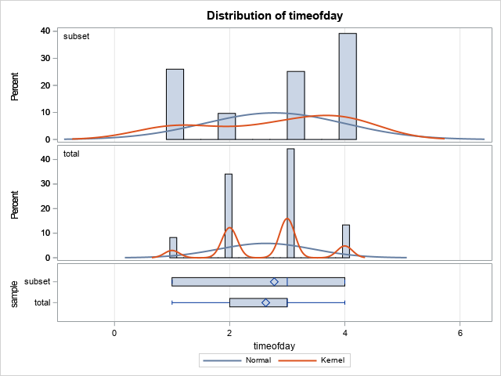

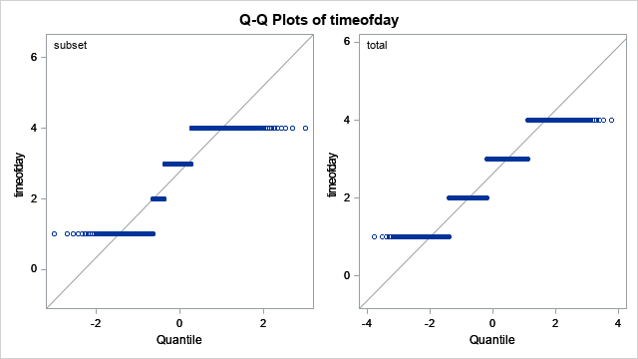

|  |
| --- |
| **Variable: datew** |

| **sample** | **Method** | **N** | **Mean** | **Std Dev** | **Std Err** | **Minimum** | **Maximum** |
| --- | --- | --- | --- | --- | --- | --- | --- |
| **subset** |  | 477 | 4.2474 | 2.1678 | 0.0993 | 1.0000 | 7.0000 |
| **total** |  | 7436 | 4.1592 | 1.8920 | 0.0219 | 1.0000 | 7.0000 |
| **Diff (1-2)** | **Pooled** |  | 0.0882 | 1.9097 | 0.0902 |  |  |
| **Diff (1-2)** | **Satterthwaite** |  | 0.0882 |  | 0.1017 |  |  |

| **sample** | **Method** | **Mean** | **95% CL Mean** | | **Std Dev** | **95% CL Std Dev** | |
| --- | --- | --- | --- | --- | --- | --- | --- |
| **subset** |  | 4.2474 | 4.0523 | 4.4424 | 2.1678 | 2.0384 | 2.3148 |
| **total** |  | 4.1592 | 4.1162 | 4.2022 | 1.8920 | 1.8621 | 1.9229 |
| **Diff (1-2)** | **Pooled** | 0.0882 | -0.0887 | 0.2650 | 1.9097 | 1.8804 | 1.9400 |
| **Diff (1-2)** | **Satterthwaite** | 0.0882 | -0.1115 | 0.2878 |  |  |  |

| **Method** | **Variances** | **DF** | **t Value** | **Pr > |t|** |
| --- | --- | --- | --- | --- |
| **Pooled** | Equal | 7911 | 0.98 | 0.3285 |
| **Satterthwaite** | Unequal | 523.58 | 0.87 | 0.3862 |

| **Equality of Variances** | | | | |
| --- | --- | --- | --- | --- |
| **Method** | **Num DF** | **Den DF** | **F Value** | **Pr > F** |
| **Folded F** | 476 | 7435 | 1.31 | <.0001 |

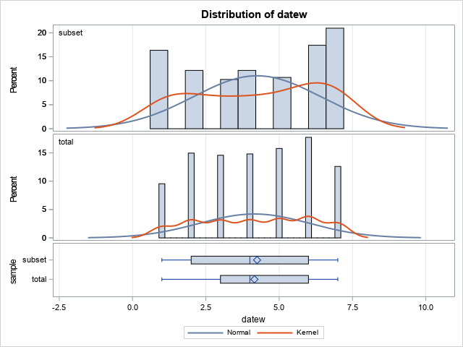

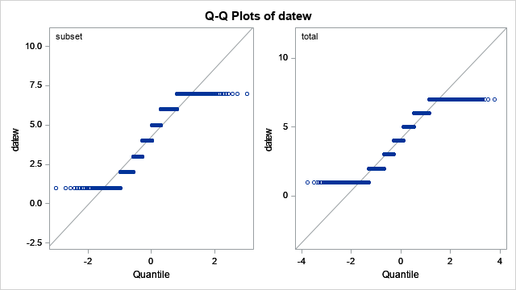

|  |
| --- |
| **Variable: impair** |

| **sample** | **Method** | **N** | **Mean** | **Std Dev** | **Std Err** | **Minimum** | **Maximum** |
| --- | --- | --- | --- | --- | --- | --- | --- |
| **subset** |  | 477 | 1.0021 | 0.0458 | 0.00210 | 1.0000 | 2.0000 |
| **total** |  | 7436 | 0.0643 | 0.2458 | 0.00285 | 0 | 2.0000 |
| **Diff (1-2)** | **Pooled** |  | 0.9378 | 0.2386 | 0.0113 |  |  |
| **Diff (1-2)** | **Satterthwaite** |  | 0.9378 |  | 0.00354 |  |  |

| **sample** | **Method** | **Mean** | **95% CL Mean** | | **Std Dev** | **95% CL Std Dev** | |
| --- | --- | --- | --- | --- | --- | --- | --- |
| **subset** |  | 1.0021 | 0.9980 | 1.0062 | 0.0458 | 0.0431 | 0.0489 |
| **total** |  | 0.0643 | 0.0587 | 0.0699 | 0.2458 | 0.2419 | 0.2498 |
| **Diff (1-2)** | **Pooled** | 0.9378 | 0.9157 | 0.9599 | 0.2386 | 0.2349 | 0.2423 |
| **Diff (1-2)** | **Satterthwaite** | 0.9378 | 0.9309 | 0.9448 |  |  |  |

| **Method** | **Variances** | **DF** | **t Value** | **Pr > |t|** |
| --- | --- | --- | --- | --- |
| **Pooled** | Equal | 7911 | 83.23 | <.0001 |
| **Satterthwaite** | Unequal | 3169.7 | 265.03 | <.0001 |

| **Equality of Variances** | | | | |
| --- | --- | --- | --- | --- |
| **Method** | **Num DF** | **Den DF** | **F Value** | **Pr > F** |
| **Folded F** | 7435 | 476 | 28.82 | <.0001 |

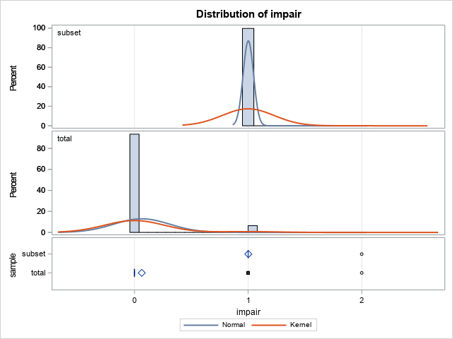

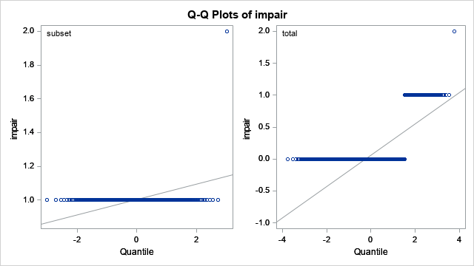

|  |
| --- |
| **Variable: surfcond** |

| **sample** | **Method** | **N** | **Mean** | **Std Dev** | **Std Err** | **Minimum** | **Maximum** |
| --- | --- | --- | --- | --- | --- | --- | --- |
| **subset** |  | 477 | 0.5996 | 1.0397 | 0.0476 | 0 | 3.0000 |
| **total** |  | 7436 | 0.6610 | 1.1207 | 0.0130 | 0 | 3.0000 |
| **Diff (1-2)** | **Pooled** |  | -0.0614 | 1.1160 | 0.0527 |  |  |
| **Diff (1-2)** | **Satterthwaite** |  | -0.0614 |  | 0.0493 |  |  |

| **sample** | **Method** | **Mean** | **95% CL Mean** | | **Std Dev** | **95% CL Std Dev** | |
| --- | --- | --- | --- | --- | --- | --- | --- |
| **subset** |  | 0.5996 | 0.5060 | 0.6931 | 1.0397 | 0.9776 | 1.1102 |
| **total** |  | 0.6610 | 0.6355 | 0.6865 | 1.1207 | 1.1030 | 1.1390 |
| **Diff (1-2)** | **Pooled** | -0.0614 | -0.1647 | 0.0419 | 1.1160 | 1.0989 | 1.1337 |
| **Diff (1-2)** | **Satterthwaite** | -0.0614 | -0.1583 | 0.0355 |  |  |  |

| **Method** | **Variances** | **DF** | **t Value** | **Pr > |t|** |
| --- | --- | --- | --- | --- |
| **Pooled** | Equal | 7911 | -1.16 | 0.2442 |
| **Satterthwaite** | Unequal | 549.41 | -1.24 | 0.2140 |

| **Equality of Variances** | | | | |
| --- | --- | --- | --- | --- |
| **Method** | **Num DF** | **Den DF** | **F Value** | **Pr > F** |
| **Folded F** | 7435 | 476 | 1.16 | 0.0295 |

